**WEEK 4 HANDS-ON**

**SPRING REST HANDSON**

**1.Hello World RESTful Web Service**

**HelloController.java**

**package** com.cognizant.spring_learn.controller;

**import** org.slf4j.Logger;

**import** org.slf4j.LoggerFactory;

**import** org.springframework.web.bind.annotation.GetMapping;

**import** org.springframework.web.bind.annotation.RestController;

@RestController

**public** **class** HelloController {

**private** **static** **final** Logger ***LOGGER*** = LoggerFactory.*getLogger*(HelloController.**class**);

@GetMapping("/hello")

**public** String sayHello() {

***LOGGER***.info("START - sayHello()");

String response = "Hello World!!";

***LOGGER***.info("END - sayHello()");

**return** response;

}

}

**Output:**

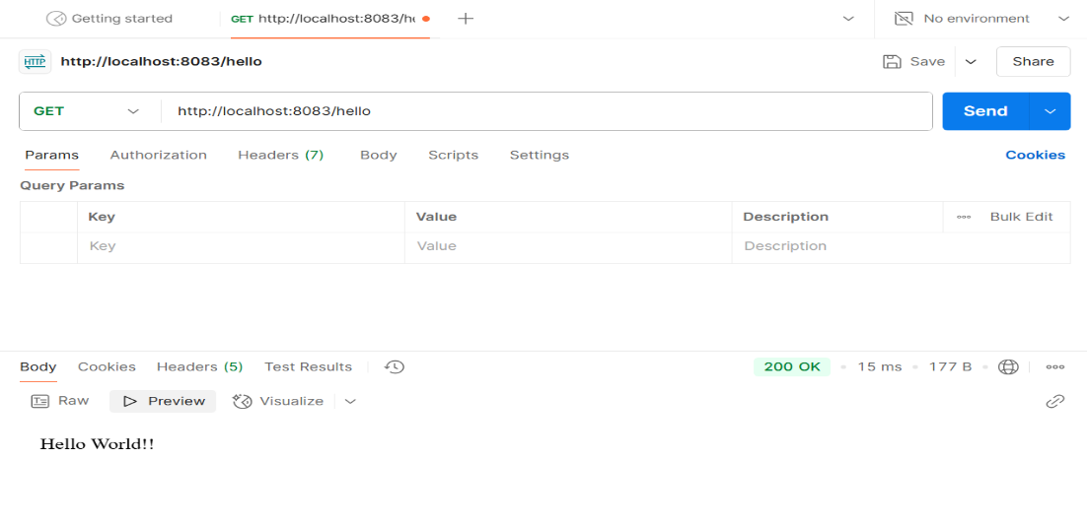

**2. REST - Country Web Service**

**CountryController.java**

**package** com.cognizant.spring_learn.controller;

**import** com.cognizant.spring_learn.Country;

**import** org.springframework.context.ApplicationContext;

**import** org.springframework.context.support.ClassPathXmlApplicationContext;

**import** org.springframework.web.bind.annotation.RequestMapping;

**import** org.springframework.web.bind.annotation.RestController;

@RestController

**public** **class** CountryController {

@RequestMapping("/country")

**public** Country getCountryIndia() {

ApplicationContext context = **new** ClassPathXmlApplicationContext("country.xml");

**return** context.getBean("country", Country.**class**);

}

}

**OUTPUT:**

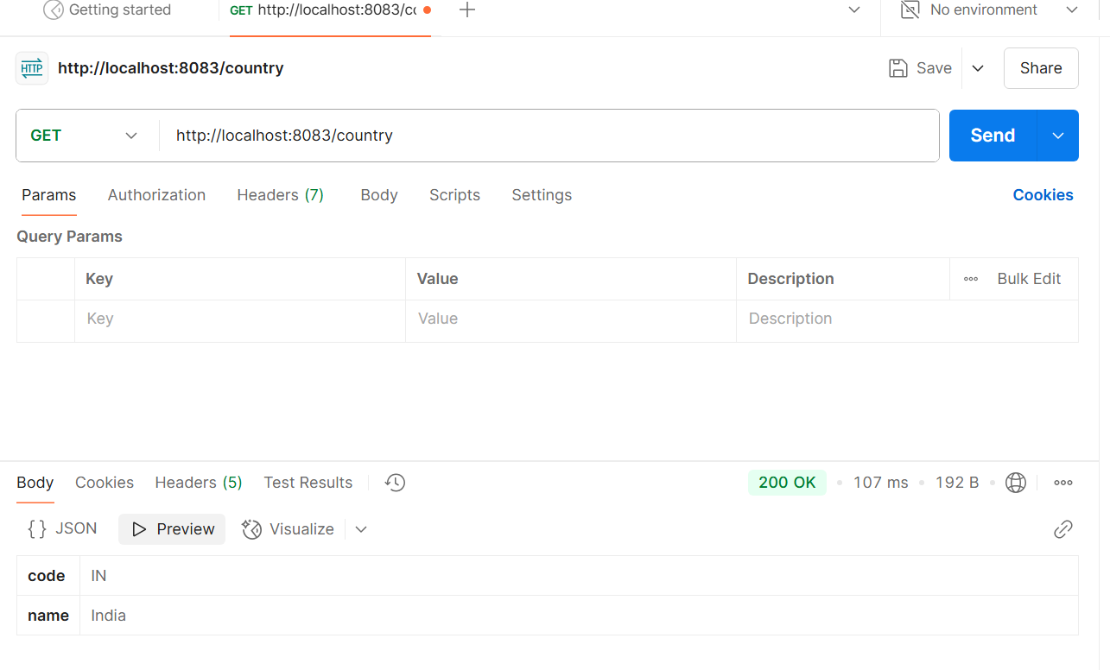

**3.REST - Get all countries**

**CountryController.java**

**package** com.cognizant.spring_learn.controller;

**import** com.cognizant.spring_learn.Country;

**import** org.springframework.beans.factory.annotation.Autowired;

**import** org.springframework.context.ApplicationContext;

**import** org.springframework.web.bind.annotation.GetMapping;

**import** org.springframework.web.bind.annotation.RestController;

**import** java.util.List;

@RestController

**public** **class** CountryController {

@Autowired

**private** ApplicationContext context;

@GetMapping("/countries")

**public** List<Country> getAllCountries() {

**return** (List<Country>) context.getBean("countryList");

}

}

**OUTPUT:**

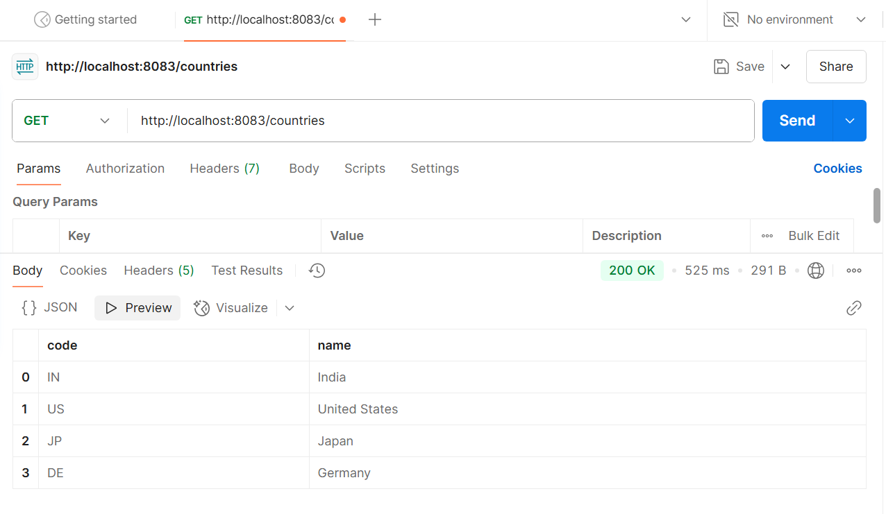

**4. REST - Get country based on country code**

**countryService.java**

**package** com.cognizant.spring_learn.service;

**import** com.cognizant.spring_learn.Country;

**import** org.springframework.context.ApplicationContext;

**import** org.springframework.context.support.ClassPathXmlApplicationContext;

**import** org.springframework.stereotype.Service;

**import** java.util.List;

@Service

**public** **class** countryService {

**public** Country getCountry(String code){

ApplicationContext context = **new** ClassPathXmlApplicationContext("country.xml");

List<Country> countries = (List<Country>) context.getBean("countryList");

**for** (Country country : countries) {

**if** (country.getCode().equalsIgnoreCase(code)) {

**return** country;

}

}

**return** **null**;

}

}

**CountryController.java**

**package** com.cognizant.spring_learn.controller;

**import** com.cognizant.spring_learn.Country;

**import** com.cognizant.spring_learn.service.countryService;

**import** org.springframework.beans.factory.annotation.Autowired;

**import** org.springframework.web.bind.annotation.*;

@RestController

**public** **class** CountryController {

@Autowired

**private** countryService countryService;

@GetMapping("/countries/{code}")

**public** Country getCountry(@PathVariable String code) {

**return** countryService.getCountry(code);

}

}

**OUTPUT:**

